

TOPIC /TITLE : INTERACTIVE CALENDAR MEMBERS : 1. CH.VANSHITHA

2.MOHAN ALANE

3.M.RITHESH RAJ

Reg .no:12207762,12210278,12214194

ROLL NUMBER:66,62,38

SECTION : “K22ST”

SUBMITTED TO :NAVJOT KAUR

TECHNOLOGY USED

•**HTML**: Hypertext Markup Language, or HTML, is a programming language used to describe the structure of information on a webpage. Together, HTML, CSS, and JavaScript make up the essential building blocks of websites worldwide, with CSS as an controlling a page’s appearance and JavaScript as an programming its functionality.

• **CSS**: CSS (Cascading Style Sheets) is a language for styling the webpage. We can change the appearance and the layout of the webpage by using CSS and we can also define how a website’s view changes in different screens like desktops, tablets, and mobile devices, etc.

• **JavaScript**: JavaScript is a client-side programming language which helps web developer to do Web Application Development and make dynamic and interactive web pages by implementing custom client-side scripts. Developers can also use cross-platform runtime engines like Node.js to write server side code in JavaScript. and can also create web pages which works well across various browsers, platforms, and devices by combining JavaScript, HTML5, and CSS3.

CREATING AN INTERACTIVE CALENDAR

**INTRODUCTION**

**I**nteractive calendars give you the ability to not only access an shared online calendar for the project but also organizes and track personal deadlines and other important tasks, events and responsibilities.

**CREATING** **AN** **INTERACTIVE** **CALENDAR** **IN** **HTML**

• Step 1: Link One of the CSS Files to Style the Calendar

• Step 2: Add the CSS That Display and Populate the

Calendar

• Step 3: Add the java Script That Display and Populate the Calendar

* Step 4: Add a Placeholder for the Calendar. ...
* Step 5: Double-Check Your Work. ...
* Step 6: Make sure your calendar is working.

ACTUAL IMPLEMENTATION

• In our project we created an interactive calendar where you can simply jot the events into the date that they're happening to ensure that you don't miss or forget anything that you might regret later such as important events, festivals, projects, etc and we added CSS and java script linking to the main code.so to get an clear idea of how its gonna look like and also it can be used in day-day life .

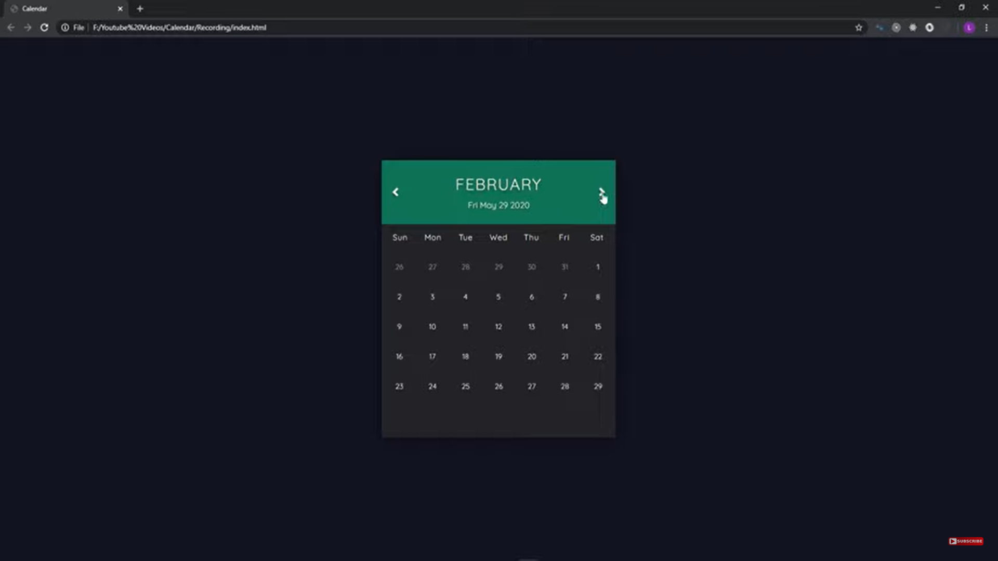 SNAPSHOTS OF INTERACTI VE CALENDAR

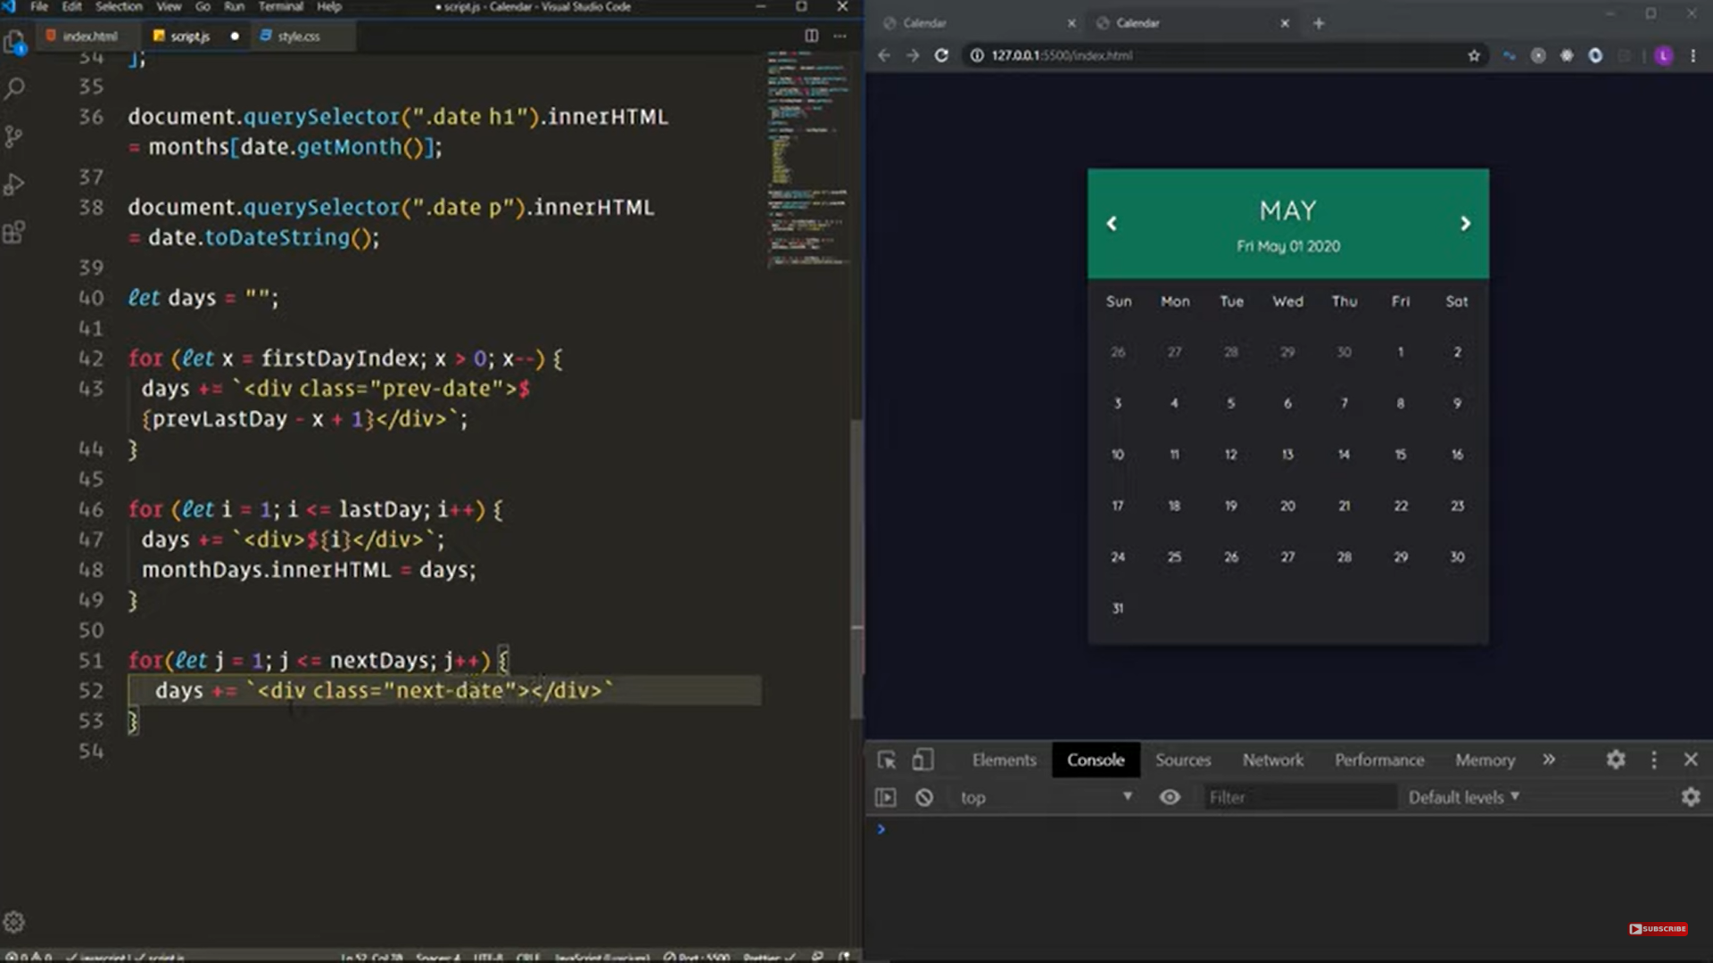

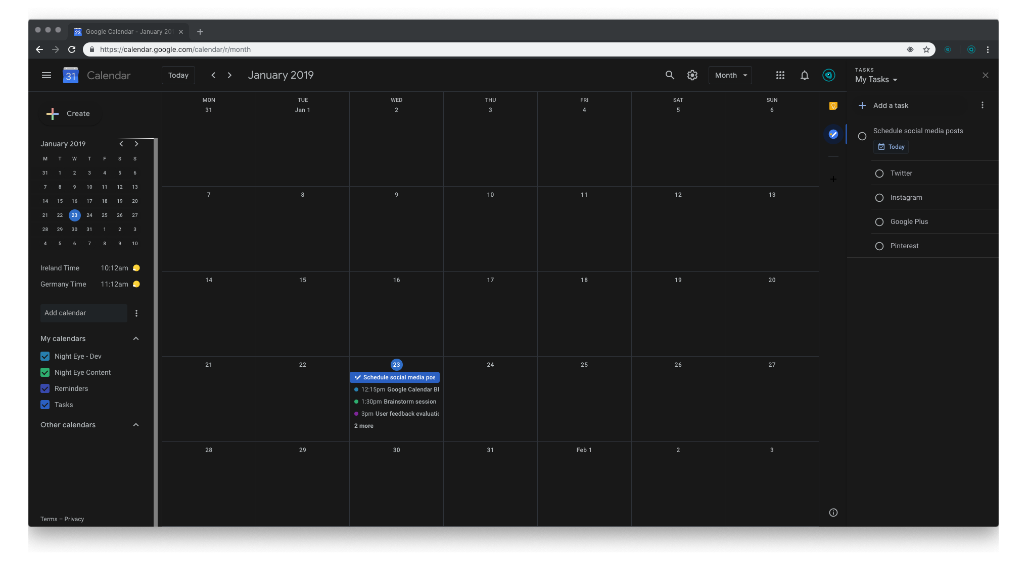

**CONCLUSION**

The aim of this thesis was to develop a website for customers to make a friendly interactive calendar ,so that customer can easily remember all the important dates and every one can get to know all important dates easily and efficiently.

**REFERENCES**

* Class ppts
* Git hub
* Google
* Youtube